Week-1 Lab programs

1. Installation of IDE Visual Studio, sublime, notepad++,

2. Design your class time table using table tags

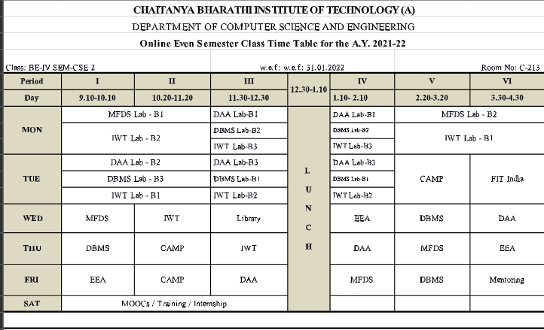

3. Design a web page which consists of image and display your biodata 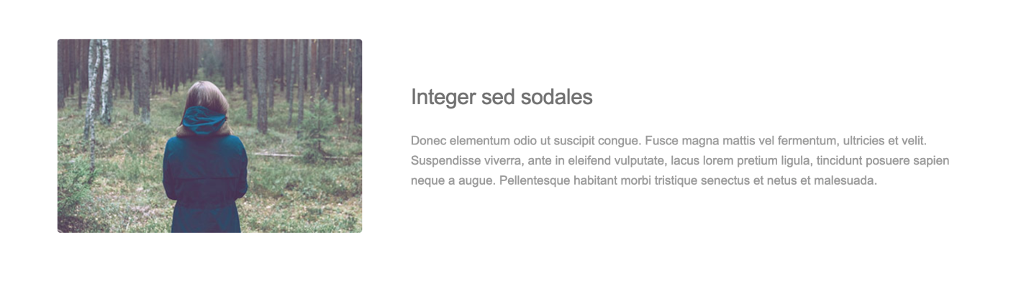

4. Create Restaurant menu card sample given below or you can design your own menu card.

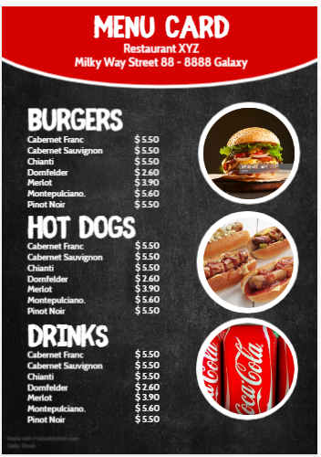

5. Design a web page to images and in one column and their description in another column using table.